Practical-12: Basic Programs Using File Handling
1) | Create, open and close a file.
 | Program :-
#include<stdio.h>
void main(){
FILE *file;
file=fopen("Demo.txt","w");
if (file!=NULL)
{
printf("Demo.txt file created");
}
fprintf(file,"Hello World");
fclose(file);
}

 | Output :-
 | 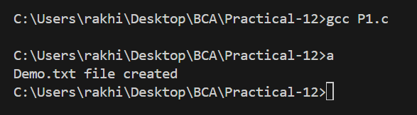
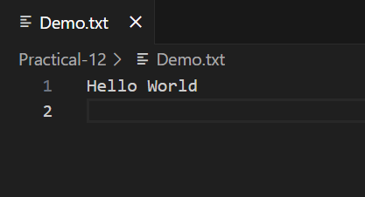

2) Count chars, spaces, tabs and new lines in a ƒile.
Program:-
#include<stdio.h>
void main(){
FILE *file;
file=fopen("Demo.txt","r");
if (file==NULL)
{
printf("File not created");
}
int char_count=0,space_count=0,tab_count=0,line_count=1;
char c=fgetc(file);
while (c!=EOF)
{
char_count++;
if(c==' '){
space_count++;
}
else if (c=='\t')
{
tab_count++;
}
else if(c=='\n'){
line_count++;
}
c=fgetc(file);
}
fclose(file);
printf("Character count: %d\n",char_count);
printf("Space count: %d\n",space_count);
printf("Tab count: %d\n",tab_count);
printf("Line count: %d\n",line_count);
}

Output:-
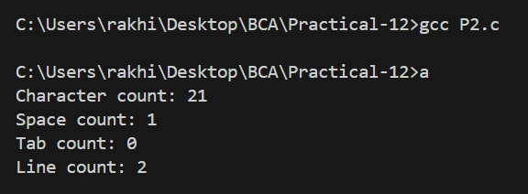
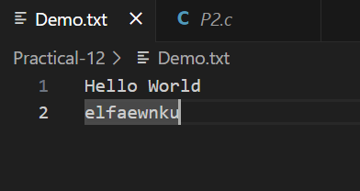

3) Demonstrate functions fprintf(), fscanf(), fputc(), fgetc(), fseek() and rewind().
Program:-
#include<stdio.h>
void main(){
FILE *file;
char str[30];
//fprint()
file=fopen("Sample.txt","w");
fprintf(file,"%s","Hello");
fclose(file);

//fscanf()
file=fopen("Sample.txt","r");
fscanf(file,"%s",str);
printf("String: %s\n",str);
fclose(file);

//fputc()
file=fopen("Sample.txt","r+");
fputc('x',file);
fclose(file);

//fgetc()
file=fopen("Sample.txt","r");
char c=fgetc(file);
printf("Character: %c\n",c);
c=fgetc(file);
printf("Character: %c\n",c);
fclose(file);

//fseek()
file=fopen("Sample.txt","r");
fseek(file,4,SEEK_SET);
c=fgetc(file);
printf("Character: %c\n",c);
fclose(file);

//frewind()
file=fopen("Sample.txt","r");
rewind(file);
c=fgetc(file);
printf("Character: %c\n",c);
fclose(file);

}

Output:-
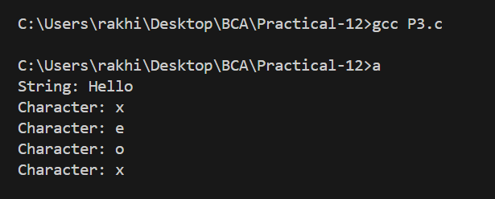
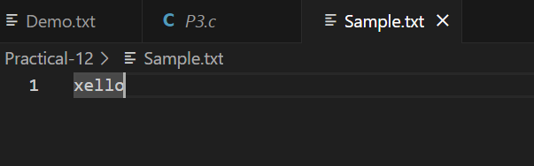

4) Print contents of ƒile in reverse order.
Program:-
#include<stdio.h>
void main(){
FILE *file;
int length=0;

file=fopen("Sample.txt","r+");

fseek(file,0,SEEK_END);
length=ftell(file);

for (int i = length-1; i >= 0; i--)
{
fseek(file,i,SEEK_SET);
char c=fgetc(file);
putchar(c);
}
fclose(file);
}

Output:-
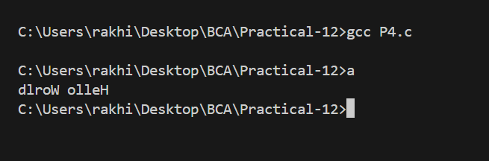
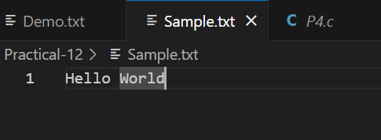

5) Capitalize ƒirst letter of each word in ƒile.
Program:-
#include <stdio.h>
#include <ctype.h>

void main() {
FILE *file;
char ch;
int flag = 1;

file = fopen("Sample.txt", "r");

printf("Capitalized String:\n");

ch=fgetc(file);

while (ch!=EOF) {
if (ch==' ') {
putchar(ch);
flag = 1;
} else if (flag) {
putchar(toupper(ch));
flag = 0;
} else {
putchar(ch);
}
ch=fgetc(file);
}
fclose(file);
}

Output:-
